BANA 656
Assignment 2
Due Date: 27th September 2024 – End of Day (word plus supporting excel file if needed)

Question
In the following MRP planning schedule for Item J, indicate the correct net requirements, planned order receipts, and planned order releases to meet the gross requirements. Lead time is one week. 1) Lot for Lot ordering is used.
2) Order size of 50 is used.

 | Week
ITEM J | 0 | 1 | 2 | 3 | 4 | 5
Gross requirements |  |  | 75 |  | 50 | 70
On-hand | 40 | 40 | 0 | 0 | 0 | 0
Net requirements |  |  | 35 |  | 50 | 70
Planned order receipt |  |  | 35 |  | 50 | 70
Planned order release |  | 35 |  | 50 | 70

Let us start with week 1. No gross requirements. There are 40 units on-hand at the beginning of week 1 because week0 shows that we have 40 units on-hand.
No demand => no net requirements
No net requirements => no planned order receipt.
Net requirement of 2nd week = gross requirement – on-hand = 75 – 40 = 35
The lead time is 1 week, so, planned order of 35 will be in week 1.
Planned order receipt of 35 will be in week 2.
Since we used all 40 on-hand we have to achieve the gross requirements, so, the on-hand of week 2 will be 0.
No gross requirements of week 3 => no net requirements in week 3 => no planned order receipt in week 3 => no planned order release in week 2.
In week 4:
Net requirements of week 4 = gross requirements – on-hand = 50 - 0 = 50.
The lead time is 1 week. So, the planned order of 50 will be in week 3.
The planned order receipt of 5o will be in week 4.
Net requirements of week 5 = gross requirements -on-hand = 70 – 0 = 70
The lead time is 1 week. So, the planned order of 70 will be in week 4.
The planned order receipt of 70 will be in week 5.

Part 2: Order size of 50 is used.

 | Week
ITEM J | 0 | 1 | 2 | 3 | 4 | 5
Gross requirements |  |  | 75 |  | 50 | 70
On-hand | 40 | 40 | 15 | 15 | 15 | 45
Net requirements |  |  | 35 |  | 35 | 55
Planned order receipt |  |  | 50 |  | 50 | 100
Planned order release |  | 50 |  | 50 | 100

Let us start with week 1. No gross requirements. There are 40 units on-hand at the beginning of week 1 because week0 shows that we have 40 units on-hand.
No demand => no net requirements
No net requirements => no planned order receipt.
Net requirement of 2nd week = gross requirement – on-hand = 75 – 40 = 35
The lead time is 1 week, so, planned order of 50*1=50 will be in week 1.
Planned order receipt of 50 will be in week 2.
On hand of week 2 will be equal to on-hand of week 1 + planned order release of week 1 – gross requirement
= 40 + 50 – 75 = 15 units on-hand in week 2.
No gross requirements of week 3 => no net requirements in week 3 => no planned order receipt in week 3 => no planned order release in week 2.
On-hand in week 3 will remain 15 units.
In week 4:
Net requirements of week 4 = gross requirements – on-hand = 50 - 15 = 35.
The lead time is 1 week. So, the planned order of 50*1 = 50 will be in week 3.
The planned order receipt of 5o will be in week 4.
On hand of week 4 will be equal to on-hand of week 3 + planned order release of week 3 – gross requirement
= 15 + 50 – 50 = 15 units on-hand in week 4.
Week 5:
Net requirements of week 5 = gross requirements -on-hand = 70 – 15 = 55.
The lead time is 1 week. So, the planned order of 50*2 =100 will be in week 4.
The planned order receipt of 100 will be in week 5.
On hand of week 5 will be equal to on-hand of week 4 + planned order release of week 4 – gross requirement
= 15 + 100 – 70 = 45 units on-hand in week 5.

Question:
One unit of A is composed of 2 units of B and three units of C. Each B is composed of one unit of F. C is made of one unit of D, one unit of E, and two units of F. Items A, B, C, and D have 20, 50, 60, and 25 units of on-hand inventory. Items A, B, and C use lot-for-lot (L4L) as their lot-sizing technique, while D, E, and F require multiples of 50, 100, and 100, respectively, to be purchased. B has scheduled receipts of 30 units in Period 1. No other scheduled receipts exist. Lead times are one period for Items A, B, and D, and two periods for Items C, E, and F. Gross requirements for A are 20 units in Period 1, 20 units in Period 2, 60 units in Period 6, and 50 units in Period 8. Find the planned order releases for all items.

To solve this problem, I will use Excel.
I set the gross requirements of A and set the tables and then made the calculations as following:
Gross requirements of B will be equal to 2*planned order release of A. Because we need 2 of B to make 1 of A.
Gross requirements of C will be equal to 3*planned order release of A. Because we need 3 of C to make 1 of A.
Gross requirements of D will be equal to 1*planned order release of C. Because we need 1 of E to make 1 of C.
Gross requirements of E will be equal to 1*planned order release of C. Because we need 1 of E to make 1 of C.
Gross requirements of F will be equal to (1*planned order release of B) + (2*planned order release of C). Because we need 1 of F to make 1 of B and we need 2 of F to make 1 of C.
Item B's scheduled receipts of 30 in period 1. The rest of schedule receipts for all items and periods is 0.
on hand = on hand of the week before + planned order receipts + scheduled receipts - gross requirement
Net requirements = gross requirement - scheduled receipts - on hand of the week before.
Planned order receipts of A, B and C will be equal to net requirements because of L4L (no specific order size multiplication)
Planned order receipts of D will be equal to the lowest multiplication of 50 that achieves the net requirements.
Planned order receipts of E will be equal to the lowest multiplication of 100 that achieves the net requirements.
Planned order receipts of F will be equal to the lowest multiplication of 100 that achieves the net requirements.
Planned order release of A, B, and D will be equal to the planned order receipt of 1 week afterwards (because the lead time is equal to 1). While Planned order release of C, E, and F will be equal to the planned order receipt of 2 weeks afterwards (because the lead time is equal to 2 periods).

All calculations are made on excel. I faced a problem in net requirements calculation but after using max function on excel, the problem was solved.
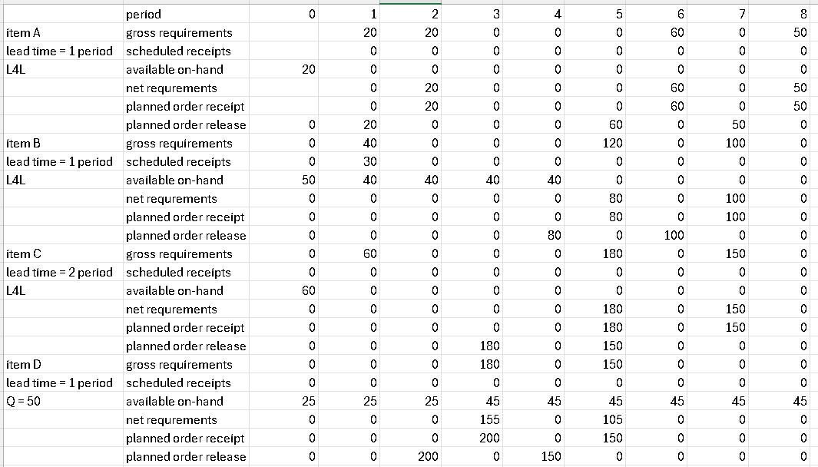
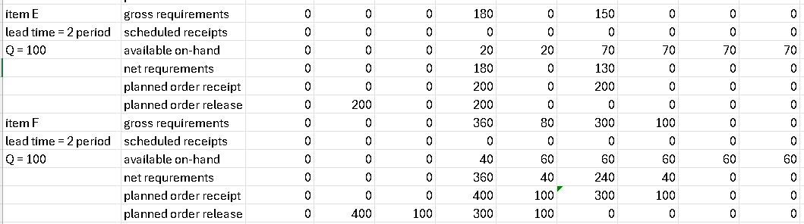

Question:
An experiment was conducted where 100 samples were taken each day for four (4) consecutive days to observe the number of defective pieces. Following data was observed:
Day | Items Defected
1 | 44
2 | 48
3 | 32
4 | 50

- which type of control chart you would use to control and monitor the above product and why?
I will choose p chart. Because the items here would either be defective or not. These numbers (44 in day, 48 in day 2, …etc) are the count of defective items. P chart is the appropriate type for such defective counts’ problems.
- Establish the control chart parameters, i.e. UCL and LCL.

First, let us calculate the proportions for each day:
Samples taken each day is 100. And the table shows the defect count of each day. Using that:
Day 1: p1=44/100 = 0.44
Day 2: p2=48/100 = 0.48
Day 3: p3=32/100 = 0.32
Day 4: p4=50/100 = 0.5

P bar = (p1 + p2 + p3 + p4)/4 = (0.44+0.48+0.32+0.5)/4 = 0.435

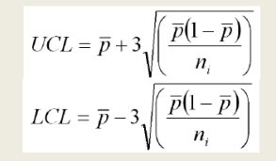

UCL = 0.435 + 3*(square root (0.435*(1-0.435)/100)) = 0.584 = 58.4%
LCL = 0.435 - 3*(square root (0.435*(1-0.435)/100)) = 0.286 = 28.
Question:
A high-tech company wants to forecast the demand for their Kindle e-readers (in 000), based on the data below.

Month | Demand (000s)
1 | 3600
2 | 3400
3 | 3400
4 | 3350
5 | 3200
6 | 2950
7 | 3050
8 | 3000
9 | 2900
10 | 2650
11 | 1850
12 | 2250
13 | 2100
14 | 1900
15 | 1850

  - The company wants to choose a forecasting method for its data and considers Simple Moving Average (4 period and 7 period) and Weighted Moving Average (4 period with w₁=0.4, w₂ = 0.3, w₃ = 0.2 and w₄ = 0.1).
    - Using the above forecasting methods, forecast demand till month 15.
  - Make a scatter plot of the forecasts obtained with the three methods (4 and 7 period simple moving average and 4 period weighted moving average), together with the actual demand. Comment on the graphs obtained.
  - For each of the three methods above, calculate MAD and MAPE. Comment on these values. Which forecasting method should you choose? Why?

The scatterplot shows that WMA (n=4), which is the 4 periods weighted moving average is the method with the closest results to the actual demand. Weight moving average was expected to give results closer to reality because it doesn’t the calculate the average, instead, it gives each sample of the historical data a different weight depends on how close to the current time it is. It gives the samples that are closer to the current time a higher weight because the most recent the sample is, the more affect it will have.
SMA (n=4) or the 4 periods using simple moving average shows less accurate results than WMA (n=4). SMA calculates the average, where it gives equal weight for all historical data, which results in not giving the most accurate results.

SMA (n=7) was showing the least accurate results between all 3 methods as we can see on the scatterplot.

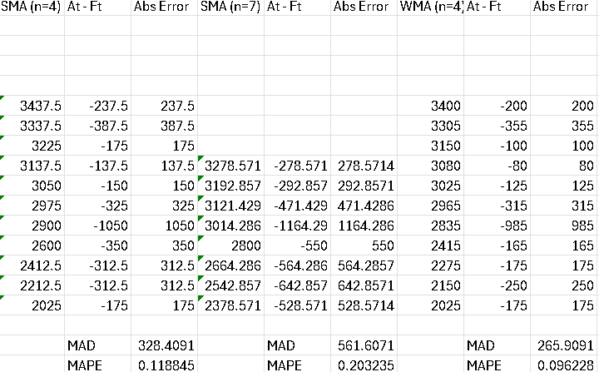

As we can see in the picture,
SMA (n=4): MAD = 328.4, MAPE = 11.88%
SMA (n=7): MAD = 561.6, MAPE = 20.32%
WMA (n=4): MAD = 265.9, MAPE = 9.62%

As we can see, weighted moving average (n=4) has the lowest MAD and the smallest percentage of MAPE. Which shows that it has lower error (more accurate results). So, the best method to use is weighted moving average(n=4) because MAP and MAPE shows that it has the lowest error, which means that it is the most accurate method among all 3 methods.

Question:
Use the data provided in Question 1, the Analyst would like to establish a Linear Regression model for the demand, Using Excel, please run linear regression on this data.

  - What is the Coefficient of Determination (R Squared)? What does it mean?
  - Use the model generate to predict the demand for Month # 16

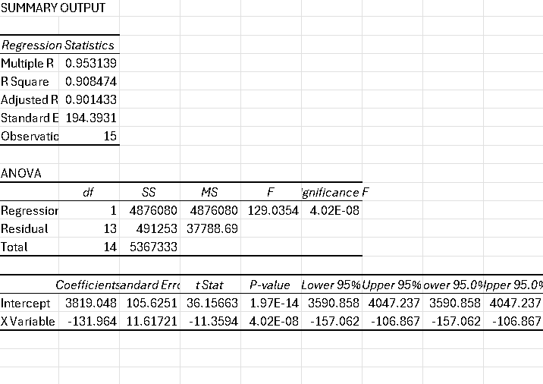

R square is 0.908474. which indicates that the variation in the dependent variable (demand) can be explained by the independent variable (month) is 90.85, which is a good percentage because the closer r square is to 100% or 1, the more the change in month can explain the change in demand.

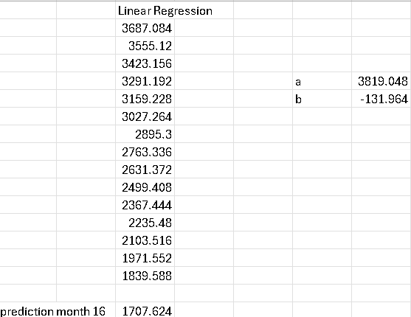

The prediction of demand in month 16 is: 1707.624 (was solved by excel)

Question:
A supply chain analyst is analyzing past sales data. He obtained the following numbers:

Week | Demand | Week | Demand
1 | 3810 | 13 | 3919
2 | 3520 | 14 | 3656
3 | 3450 | 15 | 3566
4 | 3200 | 16 | 3336
5 | 3869 | 17 | 3975
6 | 3573 | 18 | 3708
7 | 3489 | 19 | 3589
8 | 3239 | 20 | 3381
9 | 3899 | 21 | 4035
10 | 3613 | 22 | 3728
11 | 3537 | 23 | 3630
12 | 3278 | 24 | 3403

He thinks that two methods could be used to forecast future sales: linear regression and weighted moving average.

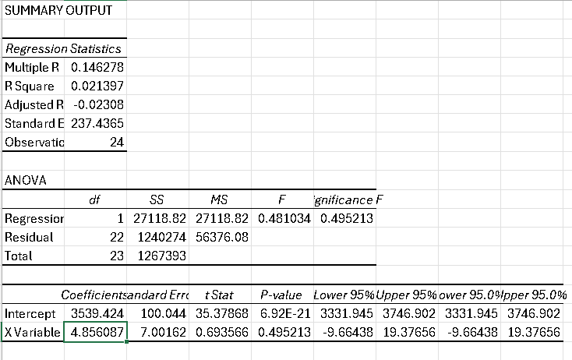
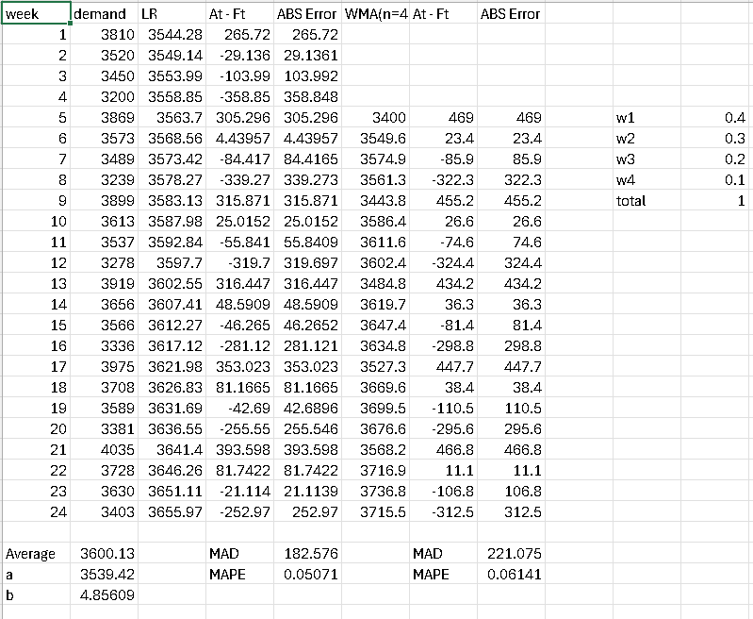

  - Using Excel, please run linear regression on this data. Based on the results you obtain; do you think that linear regression is appropriate in this case? Why?
R square is equal to 0.0213 which indicates that 2.13% of the variance in the dependent variable is explained by the independent variable. This is very low. So, the linear regression is not explaining good variability percentage of the data. Which means, linear regression is not the appropriate model to be used in this case.
  - Which forecasting method do you think is best suited to forecast this data? Why? Apply the suggested forecasting method.
The suggested forecasting method was applied on excel and the results are shown above (and also you can see it in check). Where I assumed that n=4 (like the previous questions) where w1=0.4, w2=0.3, w3=0.2, w1=0.1.

About the best forecasting method to be used in this data. Since we have seasonality in the data where a line (linear regression method) might not be the best way to forecast data. Since we have seasonality, weighted moving average would be a better way to forecast data. In my excel solving, I used n=4, maybe using n=5 or n=6 would giv3e more accurate results than n=4 weighted moving average. The reason why weighted moving average would be better than linear regression in our case is that our data has seasonality and cannot be forecasted by a line (linear regression prediction method).

